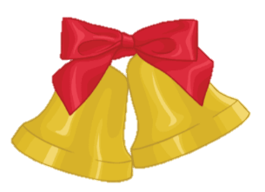
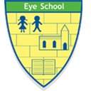
Times Table Rockstars Christmas Challenge
Have you got what it takes to be the ultimate Rock Hero this Christmas?

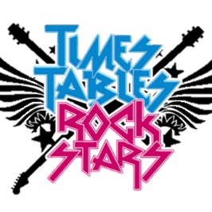
Christmas is upon us and it’s time to get into the festive spirit with some times table battles! This Christmas, aim to play against your friends as much as possible. List the name of your competitor, the battle you played and who won on this sheet. Hand it in to Miss Scane in January to win a Christmas chocolate prize! If you run out of room, write on the back.

Name of Competitor | Battle Played | Who Won?
All children who take part will win a certificate and a Christmas chocolate prize!
Name: Class:

Y

