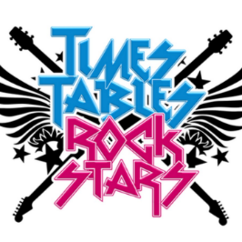
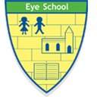
Times Table Rockstars Easter Challenge
Are you ready to play TTRockstars Easter Bingo?

Below is a TTRockstars Bingo Board. Can you play Times Table Rockstars over the Easter break to get yourself a full house (all the tasks completed)? Return your completed sheets to Miss Scane to receive your Easter challenge certificate. All completed sheets will be entered into a prize draw to win a special Easter prize! Happy Easter rockin’ Eye Primary School!

