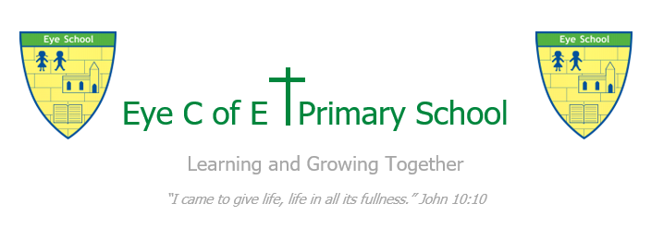
Special Educational Needs and Disability Policy
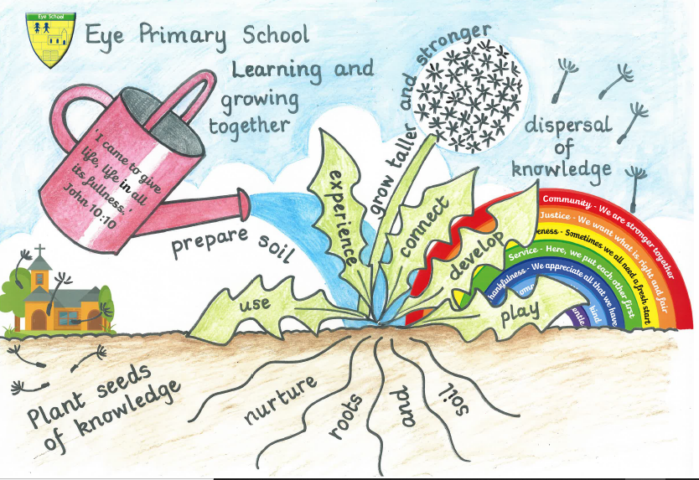
September 2024

Designated Person responsible for managing the provision for children with SEND: Mrs Lianne Thorpe, Assistant Head Teacher and SENCO

Contact details: lianne.thorpe@eye.peterborough.sch.uk

SECTION 1 – COMPLIANCE AND GENERAL STATEMENT

This policy complies with the statutory requirement laid out in the Special Educational Needs and Disabilities Code of Practice 0 – 25 Years (April 2015) and has been written with reference to the following guidance and documents:
- Equality Act 2010: advice for schools DfE Feb 2013
- SEND Code of Practice 0 -25 Years (April 2015)
- Schools SEN Information Report Regulations (2014)
- Statutory Guidance on supporting pupils at school with medical conditions (Dec 2015 Updated Aug 2017)
- Safeguarding Policy
- Accessibility Plan
- Teachers’ Standards (2012)
- United Nations Convention on Rights of the Child (1991)

This Policy has been created to ensure compliance with the Department of Education’s SEND Reforms, which address measures outlined in the Children and Families Act 2014. The Act includes changes to the support and services children and young people with special educational needs and disabilities will receive. These changes came into force on 1st September 2014. This policy has been created by Lianne Thorpe in liaison with the Headteacher, SEND Governor, SLT and staff, with due regard to the input of parents and pupils with SEND.

In compliance with the SEN Code of Practice, 2015 and SEN Reforms, there is a graduated approach to the identification, provision and support of all pupils which includes a period of close monitoring and targeted provision prior to the consideration being given to place a child onto the school Record of Need (RON). Should a pupil require provision that is additional and different they are placed on the RON under one single category, namely SEN Support. Their provision will be identified and progress monitored via Individual Provision Mapping.
This policy sets out our commitment to raising the aspirations and expectations for all pupils with SEND, including those identified as Gifted and Talented.

SECTION 2 – AIM (THE LONGER VIEW)

The overarching aim of this policy is to ensure that the needs of pupils with SEND, and the barriers to their learning, are accurately identified and effectively met so that they are able to achieve well and develop well, both as individuals and as members of the community, living life with dignity and independence. (UNCRC Article 23)
To this end, we aim to:
- Assess pupils accurately, track their progress regularly and adjust provision in the light of ongoing monitoring.
- Ensure that lessons are stimulating, enjoyable and well differentiated to meet the needs of all pupils, including those with SEND.
- Ensure that teaching and learning is multi-sensory.
- Make sure that additional support is well targeted, using a judicious blend of in-class support and withdrawal.
- Use the most appropriate resources to support learning, taking into account individual learning styles and ensuring that the development of pupils’ literacy skills has the highest priority.
- Continuously monitor and evaluate the effectiveness of our provision for all pupils, including those with SEND, to ensure that we are providing equality of educational opportunity and value for money.

Objectives:

Through the application of this policy we wish to:
- Ensure compliance with National SEND Policy, most currently the DfE SEND Reforms, Children and Families Act 2014 and the SEND Code of Practice 2015.
- Work closely with the LA in developing their Local Offer and complying with locally agreed policies and procedures.
- To operate a ‘whole pupil, whole school’ approach to the management and provision of support for SEND.
- Ensure all staff implements the school’s SEND policy consistently – fully endorsing our belief that every teacher is a teacher of every child including those with SEND.
- Ensure that there is no discrimination or prejudice.
- Ensure all pupils have access to an appropriately differentiated curriculum.
- Recognise, value and celebrate pupils’ achievements at all levels.
- Work in partnership with parents/carers in supporting their child’s education.
- Guide and support all school staff, governors and parents on SEND issues.
- Meet the individual needs of all children irrespective of whether they have physical, sensory, emotional, social, mental health, specific or general learning needs.
- Provide appropriate resources and ensure their maximum and proper use.
- Involve the pupil in the process of identification, assessment and provision and to ensure that the pupil is aware that his/her wishes are taken into account as part of the process and of the shared responsibility in meeting his/her educational needs.
- To provide an appropriately qualified Special Educational Needs Co-ordinator (SENCO) who will oversee and work with the SEND Policy.
- To provide support and advice for all staff working with pupils who have SEND.
- Support pupils with SEND to develop their personality, talents and abilities to the full. (UNCRC Article 23)
- Encourage all pupils with SEND to develop a respect for human rights, respect for parents, their own and other cultures and the environment. (UNCRC Article 29)

SECTION THREE – IDENTIFYING SPECIAL EDUCATIONAL NEEDS

A child has a learning difficulty or disability if he/she:
- greater difficulty in learning than the majority of children of his/her age.
and/or
- a disability which prevents or hinders them from making use of educational facilities/ provision that is normally available.
In addition, we identify special educational needs within the context of the usual differentiated curriculum of the school. Pupils are identified as having SEND if they are not making progress within a curriculum that:
- sets suitable learning challenges
- responds to pupils’ diverse learning needs
- aims to help pupils overcome potential barriers to learning

In accordance with the SEND Code of Practice 2015, four broad categories of need are identified:
- Communication and Interaction
- Cognition and Learning
- Sensory and/or Physical Needs
- Social, Mental and Emotional Health.

Whilst it is clear that the purpose of identification is to work out what action the School needs to take, it is not our purpose to fit a pupil into as category and serves solely to identify the needs of each individual pupil by considering the whole child, not just his/her special educational needs.

The school will always take needs that are NOT SEND but that may impact on progress and attainment into account for example:

- Attendance and Punctuality
- Health and Welfare
- EAL
- Being in receipt of Pupil Premium
- Being a Looked After Child (LAC)
- Being the child of a Serviceman/woman

The identification of behaviour as a need is not an acceptable way of describing SEND and any concerns relating to a child’s behaviour will be described as an underlying response to a need which the School has recognised and identified clearly.

SECTION 4 – A GRADUATED APPROACH TO SUPPORT OF SEND AT Eye Primary School

At Eye Primary School all teachers are responsible and accountable for the progress and development of all pupils in their class including where pupils access support from specialist staff and teaching assistants. High quality teaching, adapted for individual pupils, is the first step in responding to pupils who have SEND. ‘Quality First’ teaching is a priority of the school. It is regularly and rigorously monitored and there is a focus on continual improvement of the teaching of all pupils, including those at risk of underachievement. This includes reviewing and, where necessary, improving teachers’ understanding of strategies to identify and support vulnerable pupils and their knowledge of the SEND most frequently encountered. Close liaison is maintained with all members of staff by the SENCO to ensure that pupils are only identified as having SEND if they do not make adequate progress once they have had appropriate interventions/adjustments and good quality personalised teaching.
Details of the provision on offer at Eye Primary School can be found in the School Offer in the SEND section of the School’s Website and on the local authority website

School website information:
https://www.eyeprimaryschool.co.uk/page/?title=SEN+%26amp%3B+Disability+Provision&pid=36

LA Local offer:
Peterborough Information Network | Peterborough SEND Information Hub (Local Offer)

Levels of Need
Eye Primary School’s Graduated Response consists of three levels as follows:

Monitoring level
This refers to pupils who may, for some reason, have fallen behind and require some additional input to catch-up. A pupil in this category may have one of more of the following indicators :
- Be at risk of not meeting their targets
- Currently working at a standard below National expectations and their targets will not bring them above this level
- New entrants to the school whose needs are still being assessed
- Currently have barriers to their learning eg
    - Their behaviour is disruptive
    - There are attendance/lateness issues
    - Concerns over their mental health
    - The family is currently experiencing challenges
    - They have EAL (English as an Additional Language)

All class teachers are required to keep a list of pupils who they are monitoring at this level and to identify and implement strategies to address their needs to enable them to catch-up. This will involve conversations between the class teacher, SENCO and parents which will include problem-solving, planning support and strategies for the individual pupils.

Pupils at this level of need DO NOT form part of the School’s SEND register and, in line with the Code of Practice, the School ensures that everything is done at an early a stage as possible to avoid the need for SEN Support. However, if after a period of time, an individual does not catch-up, it is at this point that consideration will be given as to whether they need SEN support.

SEN Support
Pupils are placed on the SEND register at this level after assessment and consultation between the SENCO and Class Teacher when it is established that they have a significant learning difficulty and need provision that is additional and different.
At this point, parents/carers will be informed of the decision and the School will continue to work in partnership with them, listening their views and those of the pupil, and involving them proactively in planning and decision making. This will take the form of a half-termly ‘Assess- Plan-Do -Review Cycle.’
Assess
- Teacher’s high quality, accurate formative assessment and experience of child
- Pupil progress, attainment and behaviour
- Development & attainment in comparison to peers
- Views and experiences of parents
- The child’s own views
- If relevant, assessments, views of and advice from external services.
Plan
A plan will be drawn up by the class teacher, with the support of the SENCo, in consultation with parents and child. It will include:
- The outcomes agreed for the next term
- The support and interventions to be put in place
- The expected impact on progress, development or behaviour
- A clear date for review
- The plan will be recorded on the pupil’s APDR document.
- A copy will be given to the parents.
Do
- The class teacher remains responsible for working with the child on a daily basis
and works closely with TAs or specialist staff to plan and assess the impact of the interventions.
- The SENCo supports the class teacher in the further assessment of the child’s particular strengths and weaknesses, in problem-solving and advising on the effective implementation of support.
Review
- Parents will be invited to attend review meetings with the class teacher, the SENCo, and their child (if it is age and developmentally appropriate – if a child is does not attend this meeting, then their voice is recorded at another time and added to the document, to be shared in the review). This is timetabled to be completed, at least termly, in order to monitor/ review the effectiveness of the support and the impact on the child’s progress.
- A new the plan will then be drawn up and added to the ongoing APDR document- Parents will be given copies of all notes recorded at the review.

Involving Specialists
If a child continues to make little or no progress over a sustained period or where they continue to work at levels substantially below age expected despite SEN Support, the school will involve specialists including those from outside agencies. The views of parents/carers and the child are considered at all levels of intervention.

Education, Health and Care Plan
Pupils who need more specialist provision and whose needs cannot be wholly met at SEN Support level will be the subject of Statutory Assessment. This is applied for by the SENCO who obtains the views and information about the child from all other professionals involved in their education, health and/or care. Parents/Carers views and those of the child are obtained and will be considered so that a recommendation for an EHCP to be made to the Local Authority. The LA then consider the application and issue an EHCP as appropriate.
There is a statutory requirement to review an EHCP annually or six-monthly in the Early Years . This review meeting is held at the school with parent, child (if appropriate) and all professionals involved invited to attend.
In addition, pupils with an EHCP are subject to the Assess-Plan-Do-Review Cycle.

The SENCO is responsible for:
- Assessing specific needs of students with SEND, including application for Statutory assessment.
- Line managing the inclusion/pastoral team
- Liaising with other schools to aid transition
- Ensuring all relevant information is forwarded on to new school.
- Day-to-day operation of the School’s SEND Policy
- Liaising and advising class teachers and support staff.
- Maintaining the SEN Register and the records of all pupils with SEND.
- Liaising with parents/carers of pupils with SEND.
- Liaising with external services including the Educational Psychology Service, Social Care, Early Support etc
- Planning, attending/holding review meetings for pupils with SEND including those with an EHCP.
- Supporting the SLT for access arrangements eg additional time for KS2 SATs.

SECTION 5 - CRITERIA FOR EXITING THE SEND RECORD OF NEED

The SENCO has responsibility for the removal of a pupil from support on the SEND Register at Eye Primary School. The decision will be dependent upon appropriate progress being made towards set targets and in conjunction with appropriate teaching staff/outside agencies and parents.

SECTION 6 – SUPPORTING PUPILS AND FAMILIES

- Families of pupils with SEND are guided towards the County Council Local Authority’s Support Service eg Peterborough SEND Information Hub
https://fis.peterborough.gov.uk/kb5/peterborough/directory/localoffer.page?familychannel=8 with regard to the LA Local Offer for SEND in accordance with Regulation 51, Part 4.
- Eye Primary School has provided a link on the above website to the school’s website on which there is information on our provision for families who have a child with a SEN and/or Disability, in line with current requirements (The School Offer). The website also includes the SEN Policy and Annual SEN Information Report in accordance with Regulation 51, Part 3 section 69(3)(a) of the Act.
- Admission arrangements can be found on the school website.
- We ensure that Y6 pupils with specific SEND can access KS2 SATS. The SENCO, in liaison with the Y6 class teachers, ensures access arrangements have been made in a timely manner.
- Transition meetings between class teachers and/or Secondary School SENCOs to discuss the needs of individual pupils with SEND take place in July and will include the passing on of all records including all APDR documents.

SECTION 7 – SUPPORTING PUPILS AT EYE PRIMARY SCHOOL WITH MEDICAL CONDITIONS
- The School’s policy on managing the medical conditions of pupils can be found on the school website.
- The school recognises that pupils at school with medical conditions should be properly supported so that they can have full access to education, including educational visits and physical education. Some children with medical conditions may be disabled and where this is the case, the school will comply with its duties under the Equality Act 2010.
- Some pupils may also have SEND and may have an EHCP which brings together health and social care needs, as well as special educational provision and the Code of Practice (2015) is followed.
- The school has a number of members of staff trained in Paediatric and General First Aid and, where appropriate, staff are trained in managing the medication and other treatments of pupils with medical conditions. See the school policy for supporting Pupils with Medical Conditions for more detailed information including the name of the member of staff who leads on this aspect of care.
- The school follows guidance published by the DfE which can be found at https://assets.publishing.service.gov.uk/media/5ce6a72e40f0b620a103bd53/supporting-pupils-at-school-with-medical-conditions.pdf

SECTION 8 – MONITORINGAND EVALUATION OF SEND

Please refer to information given in Section 4 of this policy. The quality of provision offered to all pupils with SEND is continuously monitored through ongoing daily, weekly, termly and annual review, on an individual and cumulative basis in conjunction with the Governors, Headteacher, SLT, teaching staff and parents in line with an active process of continual review and improvement of whole school practice.

SECTION 9 – TRAINING AND RESOURCES

- All professional development needs are identified through the school’s appraisal system, self-evaluation and quality assurance processes and feed into the School Development Plan.
- The SENCO undertakes an annual Audit of Staff Skills and SEND Knowledge in order to recognise and address gaps within the school and for individuals.
- The Deputy Headteacher oversees the professional development of all teaching staff and teaching assistants. Training occurs during whole school training days, staff meetings and by attending courses. Colleagues attending courses are expected to disseminate and share relevant knowledge with other staff within the school.
- Newly appointed teaching and support staff undertake an induction meeting with the SENCO who will explain systems and structures in place around the school’s SEND provision and practice and to discuss the needs of individual pupils.
- The SENCO regularly attends continuing profession development training courses and hosts/attends SEND network meetings in order to keep up to date with local and national developments in SEND.
- Support Staff are encouraged to take an active part in all school functions/training including leading after-school clubs.
- Governors are encouraged to attend any SEND related training offers on the Governor training hub and the SENCO regularly attends Full Governing Body meetings to update them on any recent training and or new policies/ procedures.

SECTION 10 – ROLES AND RESPONSIBILITIES

Role of the SEND governor/Governing Body
The school’s named SEND Governor is Jemma Keegan. They can be contacted by jemma.keegan@eye.peterborough.sch.uk

The Governing body has regard to the SEN code of Practice (2015) when carrying out duties towards all pupils with SEND consequently it is their responsibility to:
- Ensure the necessary provision is made for pupils with SEND.
- Determine the school’s general policy and approach to pupils with SEND in cooperation with the Headteacher and SENCO.
- Ensure all policies linked to SEND are reviewed and in line with statutory requirements.
- Ensure that the teachers are aware of the importance of identifying and providing for those pupils with SEND.
- Ensure that the policy and information about identification, assessment, provision, monitoring and record keeping and use of outside agencies and services are available for parents.
- Ensure that the school’s progress in implementing the policy and its impact on pupils are regularly reported to the Governing Body.
- Ensure that parents are notified of a decision by the school to make SEND provision for their child.
- Ensure that pupils with SEND are included as far as possible into the activities of the school.
- Consult with the LA and the Governing bodies of other schools, when appropriate, in the interests of coordinated SEND provision in the area.

Role of the Teaching Assistants
Teaching Assistants and Higher Level Teaching Assistants are recruited to work within the classroom and/or with targeted groups or individuals outside the classroom as directed by the Senior Leaders and class teachers. The learning of all pupils, including those with SEND, remains the responsibility of the class teacher at all times.

SECTION 11 – STORING AND MANAGING INFORMATION

- The school complies with General Data Protection Regulations (GDPR) – March 2018.
- The schools uses the DfE’s Data Protection: a toolkit for schools (April 2018) as guidance.
- All staff have received GDPR training and are aware of confidentiality requirements with regard information about pupils and families.
- The SENCO understands that elements of special educational needs data are sensitive and it is the school’s policy to treat it with the same ‘high status’ as ‘Special Category Personal data’ set out in law. (see the school’s GDPR Policy and Privacy Notices.)
- Explicit consent is always sought from parents/carers for the following:
  - For the child to be put on or removed from the SEND register.
  - Involvement of outside professionals to observe/assess or work with their child eg Educational Psychologist; Speech & Language Therapist; SEND Specialists.
- The SENCO ensures that all sensitive personal information, about individual pupils and/or their families, eg their SEND file, is stored securely and is not freely accessible.
- When a pupil with SEND moves to another school, their SEND files are, wherever possible, sent electronically or delivered to the receiving school by hand and a signed file transfer receipt is required from the school. If this is not possible, the files are sent by recorded delivery post. Should the SENCo not receive the signed receipt back from the receiving school within 10 working days, this will be followed up with a phone call to the school.
- The SENCO ensures that no sensitive, personal data about individual pupils with SEND is visible anywhere in the school including, offices; staffroom and classrooms, unless it is required for Safeguarding eg medical needs such as allergies, in which case, explicit consent is gained.

SECTION 12 – REVIEWING THE SEN POLICY

The Policy will be reviewed annually to comply with requirements for SEND.

SECTION 13 – ACCESSIBILITY

Please refer to the Accessibility Plan. This can be seen on the school website.

SECTION 14 – DEALING WITH COMPLAINTS

The school’s standard complaints system applies. More information can be found on the school website.

SECTION 15 – SAFEGUARDING

Safeguarding

Children with Special Educational Needs and disabilities can face additional safeguarding challenges.
All staff at Eye Primary School are aware of these challenges. Further details can be found in the school’s Safeguarding Policy which can be viewed on the school website.

Designated Safeguarding Lead
Tracy Lee Smith
Designated Teacher for Looked After Children
Lianne Thorpe
Designated Member of Staff responsible for PPG/LAC Funding
Lottie Pollard/Jason Webster
Designated Member of Staff responsible for managing the School’s responsibility for meeting the medical needs of pupils
Tracy Lee Smith
Designated SEND Governor
Jemma Keegan

Policy Agreed:

Date ………………………………………………………………………………………….

Signed – Chair of Governors ………………………………..……………………………………………………….

Review Date …………………………………………………………………………………

